

FACULTY OF ENGINEERING AND TECHNOLOGY

BACHELOR OF TECHNOLOGY

Operating System

(303105251)

SEMESTER IV

Computer Science & Engineering Department





**OPERATING SYSTEM PRACTICAL BOOK**

**COMPUTER SCIENCE & ENGINEERING DEPARTMENT**

**PREFACE**

It gives us immense pleasure to present the first edition of the **OPERATING SYSTEM** Practical Book for the B.Tech . **4th semester** students for **PARUL UNIVERSITY.**

The **OS** theory and laboratory courses at **PARUL UNIVERSITY, WAGHODIA, VADODARA** are designed in such a way that students develop the basic understanding of the subject in the theory classes and then try their hands on the experiments to realize the various implementations of problems learnt during the theoretical sessions. The main objective of the **OS** laboratory course is: Learning **OS** through Experimentations. All the experiments are designed to illustrate various problems in different areas of **OS** and also to expose the students to various uses.

The objective of this **OS** Practical Book is to provide a comprehensive source for all the experiments included in the **OS** laboratory course. It explains all the aspects related to every experiment such as: basic underlying concept and how to analyze a problem. It also gives sufficient information on how to interpret and discuss the obtained results.

We acknowledge the authors and publishers of all the books which we have consulted while developing this Practical book. Hopefully this **OS** Practical Book will serve the purpose for which it has been developed.

### INSTRUCTIONS TO STUDENTS

1. The main objective of the **OS** laboratory is: Learning through the Experimentation. All the experiments are designed to illustrate various problems in different areas of **OS** and also to expose the students to various problems and their uses.
2. Be prompt in arriving at the laboratory and always come well prepared for the practical.
3. Every student should have his/her individual copy of the **OS** Practical Book.
4. Every student have to prepare the notebooks specifically reserved for the **OS** practical work: ”**OS** Practical Book”
5. Every student has to necessarily bring his/her **OS** Practical Book, **OS** Practical Class Notebook and **OS** Practical Final Notebook.
6. Finally find the output of the experiments along with the problem and note results in the **OS** Practical Notebook.
7. The grades for the **OS** practical coursework will be awarded based on our performance in the laboratory, regularity, recording of experiments in the **OS** Practical Final Notebook, lab quiz, regular viva-voce and end-term examination

**CERTIFICATE**

*This is to certify that*

*Mr./Ms* ***MEEN BAHADUR BUDHA****, Enrolment No*

***2303051050439****, has successfully Completed his/her laboratory experiments in the* **OPERATING SYSTEM (303105251)**

*from the department of* ***CSE*** *during The academic year* ***2024-25***

Date of Submission:......................... Staff In charge:...........................

Head Of Department:...........................................

**TABLE OF CONTENTS**

| **Sr. No** | **Experiment Title** | **Page No** | | **Date of Performance** | **Date of Assessment** | **Sign** | **Marks**  **(out of 10)** |
| --- | --- | --- | --- | --- | --- | --- | --- |
| **From** | **To** |
| 1 | Study of Basic commands of Linux. |  |  |  |  |  |  |
| 2 | Study the basics of shell programming. |  |  |  |  |  |  |
| 3 | Write a Shell script to print the given numbers sum of all digits. |  |  |  |  |  |  |
| 4 | Write a shell script to validate the entered date. (eg. Date format is: dd-mm-yyyy). |  |  |  |  |  |  |
| 5 | Write a shell script to check if the entered string is palindrome or not. |  |  |  |  |  |  |
| 6 | Write a Shell script to say Good morning/Afternoon/Evening as you log in to the system. |  |  |  |  |  |  |
| 7 | Write a C program to create a child process. |  |  |  |  |  |  |
| 8 | Finding out biggest number from given three numbers supplied as command line arguments. |  |  |  |  |  |  |
| 9 | Printing the patterns using for loop. |  |  |  |  |  |  |
| 10 | Shell script to determine whether a given file exists or not. |  |  |  |  |  |  |
| 11 | Write a program for process creation using C. (Use of gcc compiler). |  |  |  |  |  |  |
| 12 | Implementation of FCFS & Round Robin Algorithm. |  |  |  |  |  |  |
| 13 | Implementation of Banker's Algorithm. |  |  |  |  |  |  |

# PRACTICAL 1

**AIM:-**Study of Basic commands of Linux.

**Command shell:** A program that interprets commands is Command shell.

**Shell Script:**Allows a user to execute commands by typing them manually at a terminal, or automatically in programs called shell scripts.A shell is not an operating system. It is a way to interface with the operating system and run Commands.

#### BASH (Bourne Again Shell)

* Bash is a shell written as a free replacement to the standard Bourne Shell (/bin/sh) originally written by Steve Bourne for UNIX systems.
* It has all of the features of the original Bourne Shell, plus additions that make it easier to program with and use from the command line.
* Since it is Free Software, it has been adopted as the default shell on most Linux systems.

## BASIC LINUX COMMANDS:

#### Pwd : print working directory DESCRIPTION:

pwd prints the full pathname of the current working directory.

### SYNTAX:

Pwd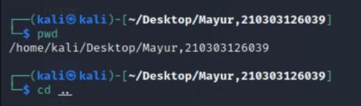

#### cd: Change Directory DESCRIPTION:

It allows you to change your working directory. You use it to move around within the hierarchy of your file system.

### SYNTAX:

cd directory_name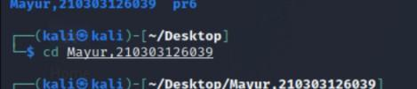

#### cd .. DESCRIPTION:

Move up one directory.

### SYNTAX:

cd ..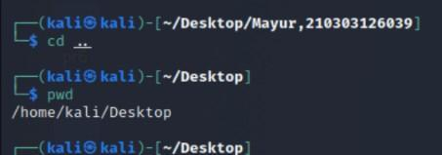

#### ls : list all the files and directories DESCRIPTION:

List all files and folders in the current directory in the column format.

### SYNTAX:

ls [options]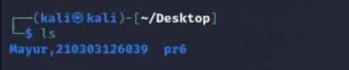

#### cat DESCRIPTION:

cat stands for "catenate". It reads data from files, and outputs their contents. It is the simplest way to display the contents of a file at the command line.

### SYNTAX:

cat filename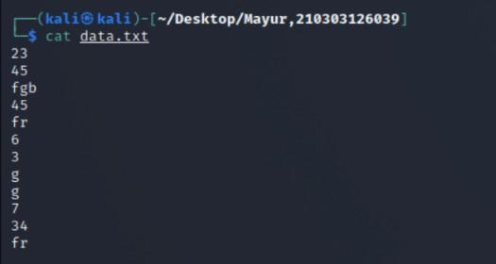

#### head DESCRIPTION:

head, by default, prints the first 10 lines of each FILE to standard output. With more than one FILE, it precedes each set of output with a header identifying the file name.

If no FILE is specified, or when FILE is specified as a dash ("-"), head reads from standard input.

### SYNTAX:

head [option]...[file/directory]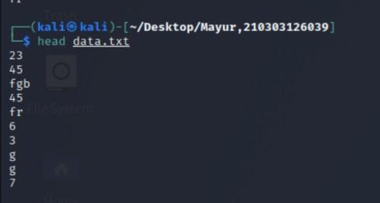

1. **Tail**

### DESCRIPTION:

tail is a command which prints the last few number of lines (10 lines by default) of a certain file, then terminates.

### SYNTAX:

tail [option]...[file/directory]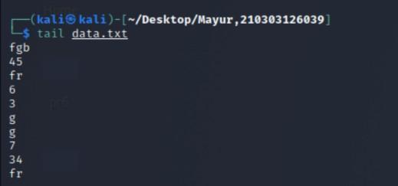

#### mv : Moving (and Renaming) Files DESCRIPTION:

The mv command lets you move a file from one directory location to another. It also lets you rename a file (there is no separate rename command).

### SYNTAX:

mv [option] source directory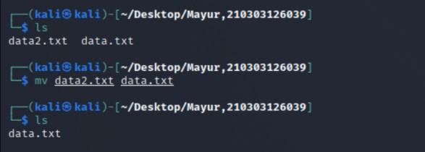

#### mkdir : Make Directory DESCRIPTION:

If the specified directory does not already exist, mkdir creates it. More than one directory may be specified when calling mkdir.

### SYNTAX:

mkdir [option] directory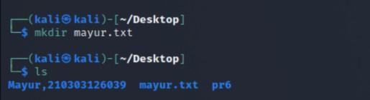

#### cp : Copy Files DESCRIPTION:

The cp command is used to make copy of files and directories.

### SYNTAX:

cp [option] source directory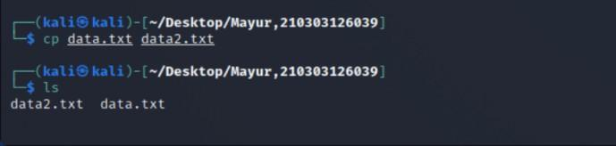

#### rmdir : Remove Directory DESCRIPTION:

The rmdir command is used to remove a directory that contains other files or directories.

### SYNTAX:

rm directory_name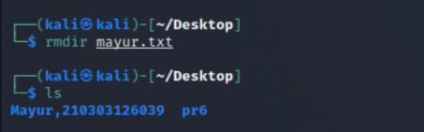

#### gedit DESCRIPTION:

The gedit command is used to create and open a file.

### SYNTAX:

#### man DESCRIPTION:

Displays on an online manual page or manpage.

### SYNTAX:

man command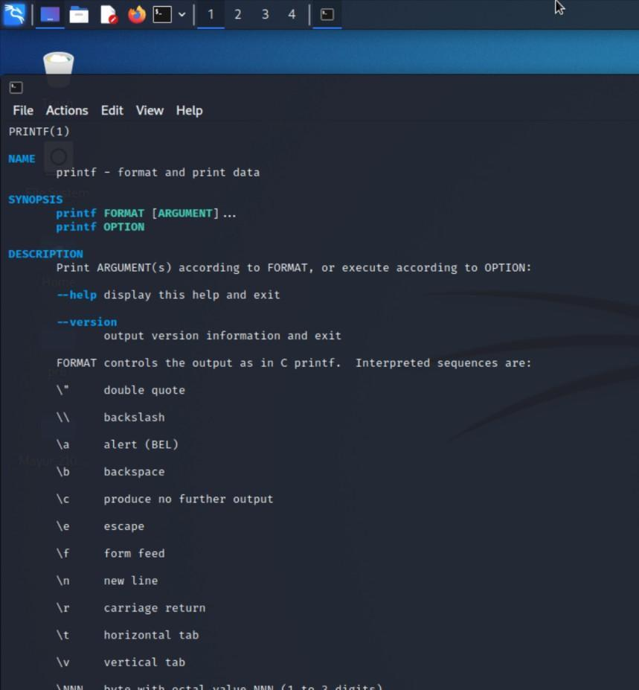

#### echo DESCRIPTION:

Display text on the screen.

### SYNTAX:

echo yourtext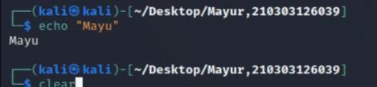

#### clear DESCRIPTION:

Used to clear the screen

### SYNTAX:

Clear

#### whoami DESCRIPTION:

whoami prints the effective user ID. This command prints the username associated with the current effective user ID.

### SYNTAX:

whoami [option]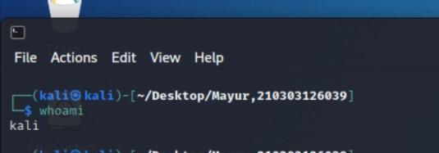

1. **wc**

### DESCRIPTION:

wc (word count) command, can return the number of lines, words, and characters in a file.

### SYNTAX:

wc [option]... [file]...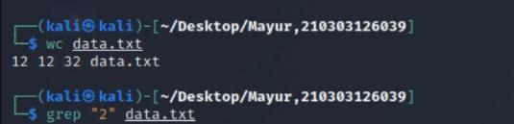

#### grep DESCRIPTION:

grep command uses a search term to look through a file.

### SYNTAX:

grep [option]... Pattern [file]...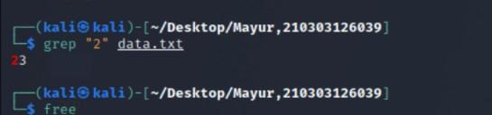

#### free DESCRIPTION:

Display RAM details in Linux machine.

**SYNTAX:** Free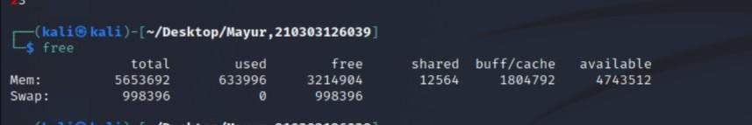

#### pipe ( | ) DESCRIPTION:

Pipe command is used to send output of one program as a input to another. Pipes “|” help combine 2 or more commands.

### SYNTAX:

Command 1 | command 2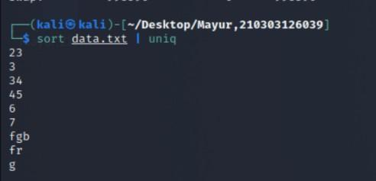

# PRACTICAL 2

**AIM:-**Study the basics of shell programming.

#### What is a Shell?

An Operating is made of many components, but its two prime components are -

* Kernel
* Shell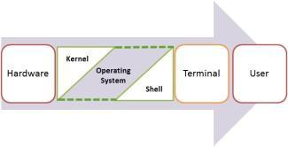

A Kernel is at the nucleus of a computer. It makes the communication between the hardware and software possible. While the Kernel is the innermost part of an operating system, a shell is the outermost one.

A shell in a Linux operating system takes input from you in the form of commands, processes it, and

then gives an output. It is the interface through which a user works on the programs, commands, and

scripts. A shell is accessed by a terminal which runs it.

When you run the terminal, the Shell issues a command prompt (usually $), where you can type

your input, which is then executed when you hit the Enter key. The output or the result is thereafter

displayed on the terminal.

The Shell wraps around the delicate interior of an Operating system protecting it from accidental damage. Hence the name Shell.

#### Types of Shell

There are two main shells in Linux:

#### The Bourne Shell: The prompt for this shell is $ and its derivatives are listed below:

* + POSIX shell also is known as sh
  + Korn Shell also knew as sh
  + **B**ourne **A**gain **SH**ell also knew as bash (most popular)

1. **The C shell**: The prompt for this shell is %, and its subcategories are:

* C shell also is known as csh
* Tops C shell also is known as tcsh

**What is Shell Scripting?**

Shell scripting is writing a series of command for the shell to execute. It can combine lengthy and repetitive sequences of commands into a single and simple script, which can be stored and executed anytime. This reduces the effort required by the end user.

Let us understand the steps in creating a Shell Script

1. **Create a file using** a **vi** editor(or any other editor). Name script file with **extension**

**.sh**

1. **Start** the script with **#! /bin/sh**
2. Write some code.
3. Save the script file as filename.sh
4. For **executing** the script type **bash filename.sh**

"#!" is an operator called shebang which directs the script to the interpreter location. So, if we use"#! /bin/sh" the script gets directed to the bourne-shell.

Let's create a small script -

#!/bin/sh ls

Let's see the steps to create it –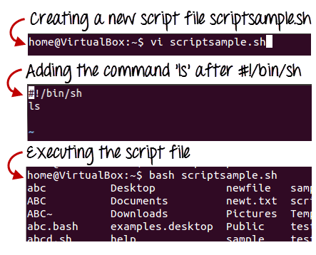

Command 'ls' is executed when we execute the scrip sample.sh file. Adding shell comments

Commenting is important in any program. In Shell programming, the syntax to add a comment is #comment

Let understand this with an example.

#### What are Shell Variables?

As discussed earlier, Variables store data in the form of characters and numbers. Similarly, Shell variables are used to store information and they can by the shell only.

For example, the following creates a shell variable and then prints it: variable ="Hello"

echo $variable

Below is a small script which will use a variable. #!/bin/sh

echo "what is your name?" read name

echo "How do you do, $name?" read remark

echo "I am $remark too!"

Let's understand, the steps to create and execute the script

As you see, the program picked the value of the variable 'name' as Joy and 'remark' as excellent. This is a simple script. You can develop advanced scripts which contain conditional statements, loops, and functions. Shell scripting will make your life easy and Linux administration a breeze. **Summary:**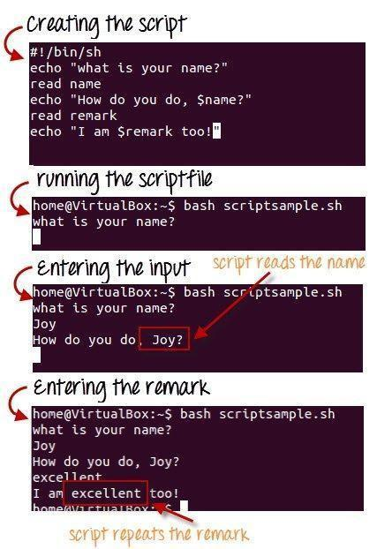

* Kernel is the nucleus of the operating systems, and it communicates between hardware and

software

* Shell is a program which interprets user commands through CLI like Terminal
* The Bourne shell and the C shell are the most used shells in Linux
* Shell scripting is writing a series of command for the shell to execute
* Shell variables store the value of a string or a number for the shell to read
* Shell scripting can help you create complex programs containing conditional statements, loops, and functions

**# Aim: -** Write a shell script to make addition of two Numbers

## # Input: -

#!/bin/bash

echo " Write a Program to Addition Of two Number " echo " Enter the First Number"

read a

echo " Enter the second Number " read b

c=$(($a+$b)) echo $c **#Output:-**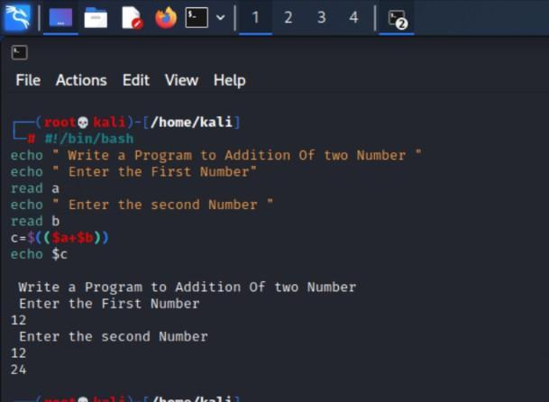

**# Aim: -** Write a shell script to make subtraction of two Numbers

## # Input: -

#!/bin/bash

echo " Write a Program to subtraction of two Number " echo " Enter the First Number"

read a

echo " Enter the second Number " read b

c=$(($a-$b)) echo $c

## #Output:-

**# Aim: -** Write a shell script to make multiplication of two Numbers

## # Input: -

#!/bin/bash

echo " Write a Program to multiplication of two Number " echo " Enter the First Number"

read a

echo " Enter the second Number " read b

c=$(($a*$b)) echo $c **#Output:-**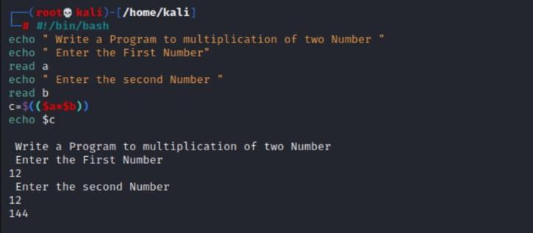

**# Aim: -** Write a shell script to make division of two Numbers

## # Input: -

#!/bin/bash

echo " Write a Program to do division of two Number " echo " Enter the First Number"

read a

echo " Enter the second Number "

read b c=$(($a/$b)) echo $c **#Output:-**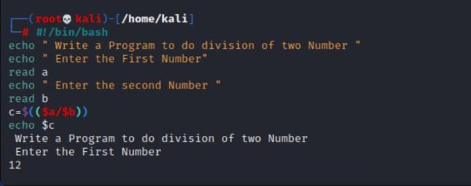

**# Aim: -** Write a shell script to make modulus of two Numbers

## # Input: -

#!/bin/bash

echo " Write a Program to find modulus of two numbers " echo " Enter the First Number"

read a

echo " Enter the second Number " read b

c=$(($a%$b)) echo $c **#Output:-**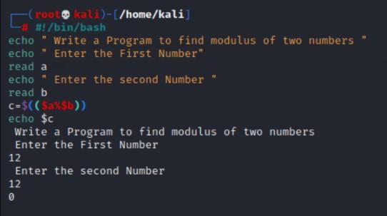

**# Aim: -** Write a shell script to type name

## # Input: -

#!/bin/bash

echo " Enter Your Name " read name

echo "Your name is "$name

## #Output:-

**# Aim: -** Write a shell script to find swap of 2 numbers

## # Input: -

#!/bin/bash

echo "Enter the First Number" read first

echo "Enter the Second Number" read second

temp=$first first=$second second=$temp

echo "After swapping, numbers are:" echo "first = $first, second = $second"

## #Output:-

**# Aim: -** Write a shell script to define variable

## # Input: -

#!/bin/bash

echo " What is your name?" read MY_NAME

echo " Hello, I'm "$MY_NAME". I Hope you are well"

**#Output:-**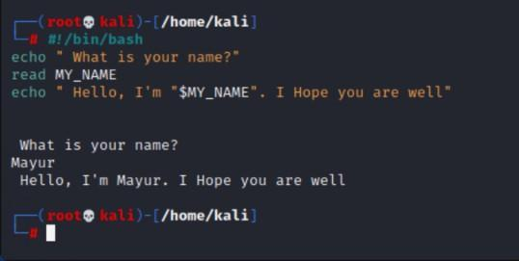

# PRACTICAL 3

**AIM:-**Write a Shell script to print the given numbers sum of all digits.

## # Input: -

#!/bin/bash

echo "Enter a number" read num

sum=0

while [ $num -gt 0 ] do

mod=$((num % 10)) sum=$((sum + mod)) num=$((num / 10)) done

echo $sum

**#Output:-**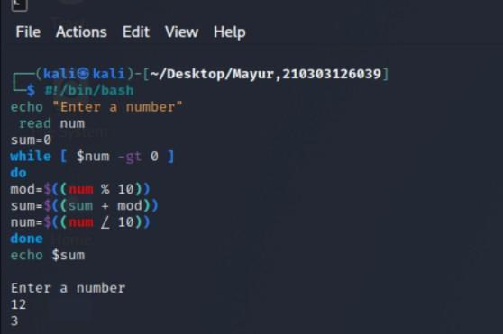

# PRACTICAL 4

**AIM:-**Write a shell script to validate the entered date. (eg. Date format is: dd-mm-yyyy).

## # Input: -

#!/bin/bash

d=`date +%m-%d-%Y` echo $d #DD-MM-YYYY echo " Please Enter Date " read D

echo " Please Enter Month " read M

echo " Please Enter Year " read Y

if [ `expr $Y % 4` -eq 0 ] then

Mayur Pandya Division: - 4B18 echo "$Y is a leap year"

else

echo "$Y is not a leap year" fi

**#Output:-**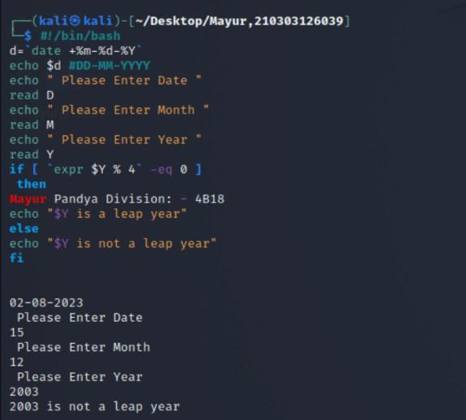

# PRACTICAL 5

**AIM:-.**Write a shell script to check entered string is palindrome or not

## # Input: -

#!/bin/bash

# Store the string entered by the user echo -n "Enter a string: "

read str

# Reverse the string revstr=$(echo $str | rev)

# Check if the string is a palindrome if [ "$str" == "$revstr" ]

then

echo "The string is a palindrome" else

echo "The string is not a palindrome" fi

**#Output:-**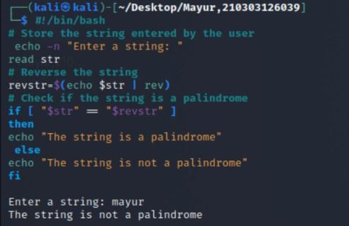

# PRACTICAL 6

**AIM:-**.Write a Shell script to say Good morning/Afternoon/Evening as you log in to the system**.**

## # Input: -

#!/bin/bash

# Get the current hour hour=$(date +%H) name=" Mayur Pandya "

# Set the greeting message

if [ $hour -ge 6 ] && [ $hour -lt 12 ]; then greeting="Good morning $name"

elif [ $hour -ge 12 ] && [ $hour -lt 16 ]; then greeting="Good afternoon $name"

elif [ $hour -ge 16 ] && [ $hour -lt 20 ]; then greeting="Good evening $name"

else

greeting="Good Night $name" fi

# Print the greeting message echo $greeting

**#Output:-**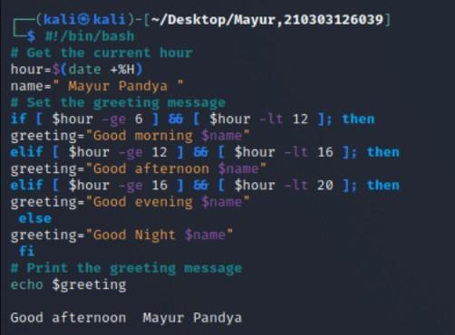

# PRACTICAL 7

**AIM:-** Write a C program to create a child process.

## # Input: -

**#include <stdio.h>**

**#Output:-**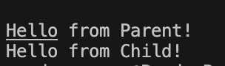

# PRACTICAL 8

**AIM:-** Finding out biggest number from given three numbers supplied as command line arguments.

## # Input: -

echo "Enter Num1" read num1

echo "Enter Num2" read num2

echo "Enter Num3" read num3

if [ $num1 -gt $num2 ] && [ $num1 -gt $num3 ] then

echo $num1

elif [ $num2 -gt $num1 ] && [ $num2 -gt $num3 ] then

echo $num2 else

echo $num3 fi

**#Output:-**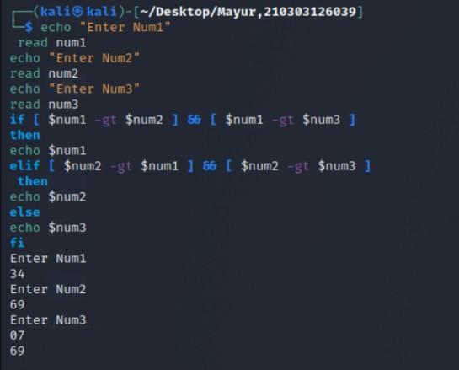

# PRACTICAL 9

**AIM:-** Printing the patterns using for loop

## # Input: -

# Static input for N N=5 N=5

i=0

while [ $i -lt $N ] do

j=0

while [ $j -lt $N ] do

if [ $((N-1-i)) -le $j ] then

# Print the pattern echo -ne "/"

else

# Print the spaces required echo -ne " "

fi

j=$((j + 1)) done

echo

i=$((i + 1)) done **#Output:-**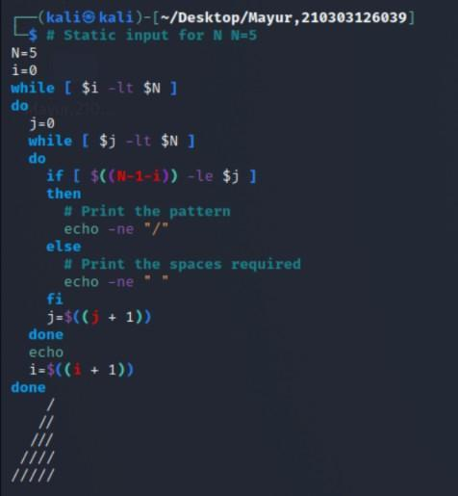

# PRACTICAL 10

**AIM:-** Shell script to determine whether a given file exists or not.

**# Input: -** #!/bin/bash File=dp.txt

if [ -f "$File" ]; then echo "$File exists" else

echo "$File does not exist" fi

**#Output:-**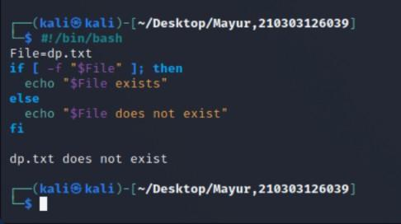

# PRACTICAL 11

**AIM:-** Write a program for process creation using C. (Use of gcc compiler).

## # Input: -

**#include <stdio.h>**

**#Output:-**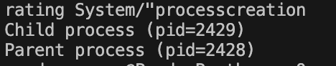

# PRACTICAL 12

**AIM:-** Implementation of FCFS &Round Robin Algorithm

## # Input: - FCFS

**#include <stdio.h>**

## #Output:-

**# Input: - RR**

**#include <stdio.h>**



**#Output:-**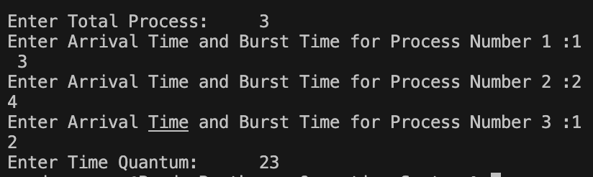

# PRACTICAL 13

**AIM:-** Implementation of Banker's Algorithm.

**# Input: -** #include <stdio.h> #include <stdlib.h>

int main()

{

int Max[10][10], need[10][10], alloc[10][10], avail[10], completed[10]; int p, r, i, j, process, count;

count = 0;

printf("Enter the number of processes: "); scanf("%d", &p);

for (i = 0; i < p; i++)

{

completed[i] = 0;

}

printf("\nEnter the number of resources: "); scanf("%d", &r);

printf("\nEnter the Max Matrix for each process:\n"); for (i = 0; i < p; i++)

{

printf("For process %d: ", i + 1); for (j = 0; j < r; j++)

{

scanf("%d", &Max[i][j]);

}

}

printf("\nEnter the allocation for each process:\n"); for (i = 0; i < p; i++)

{

printf("For process %d: ", i + 1); for (j = 0; j < r; j++)

{

scanf("%d", &alloc[i][j]);

}

}

printf("\nEnter the available resources: "); for (i = 0; i < r; i++)

{

scanf("%d", &avail[i]);

}

printf("\nMax Matrix\tAllocation Matrix\n"); for (i = 0; i < p; i++)

{

for (j = 0; j < r; j++)

{

printf("%d ", Max[i][j]);

}

printf("\t\t");

for (j = 0; j < r; j++)

{

printf("%d ", alloc[i][j]);

}

printf("\n");

}

return 0;}